App in a Day

Hands-on Lab Step-by-Step

December 2019

Contents

Complete Solution 1

Task 1: Create a new environment 1

Task 2: Import the solution 2

Task 3: Import the application 4

Task 4: Import Flow 9

# Complete Solution

Follow the steps below to see the complete solution without completing the modules

## Task 1: Create a new environment

1. Open a new browser tab, navigate to <https://admin.powerapps.com> select **Environments** and click **New Environment**.

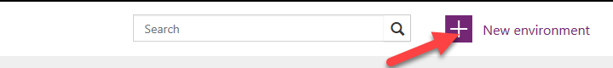

1. Provide an **Environment Name**, select **Region**, select **Environment Type**, and click **Create Environment**.

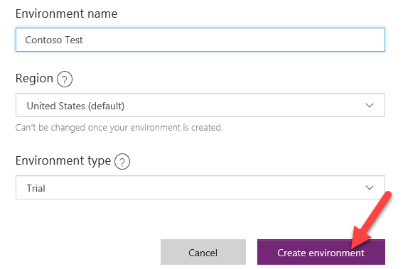

1. Click **Create Database**.

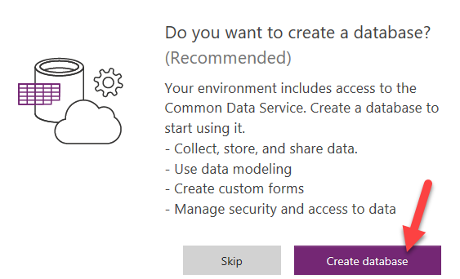

1. Select **Currency** and **Language**, and then click **Create Database**.

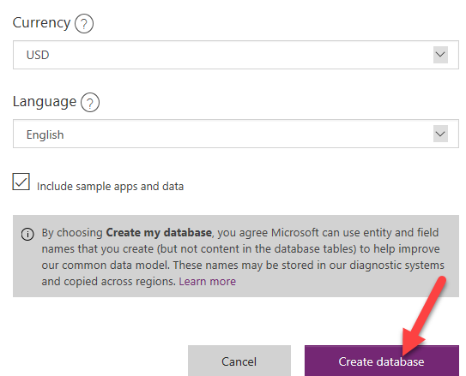

Wait for the Database to be created

## Task 2: Import the solution

In this task, you will import the completed module 3 solution.

1. Open a new browser tab, navigate to <https://make.powerapps.com>
2. Make sure to select the correct environment.



1. Click **Projects** and click **Import**.

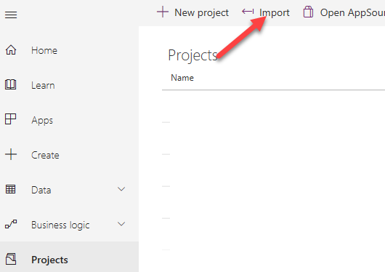

1. Click **Browse**.

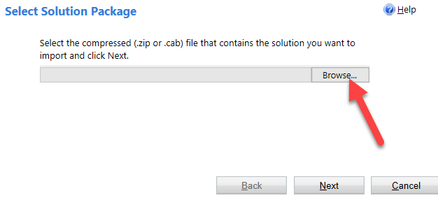

1. Select the Module 4 Completed Solution zip file located in Module 4 Complete Solution folder and click **Open**.

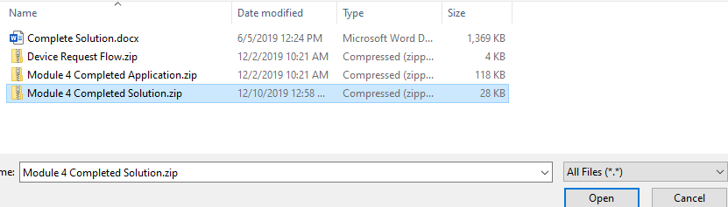

1. Click **Next**.

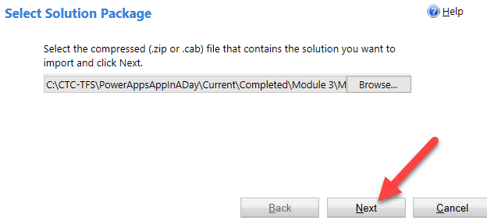

1. Click **Next**.

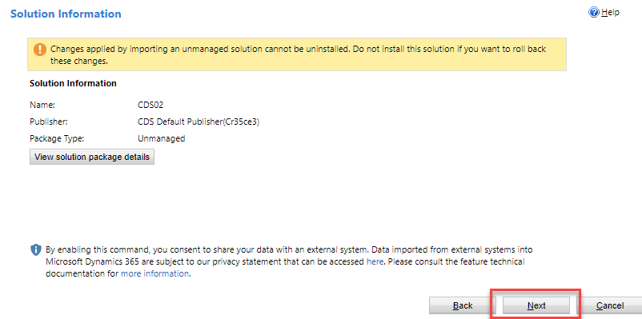

1. Click **Import**.

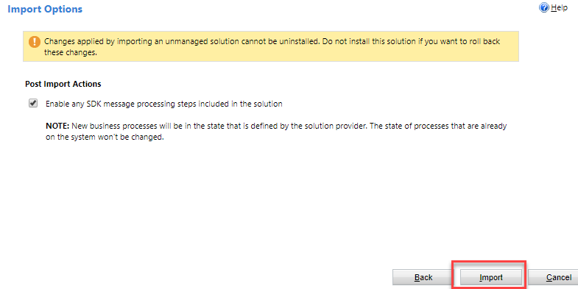

1. Wait for the solution import to complete and click Close.

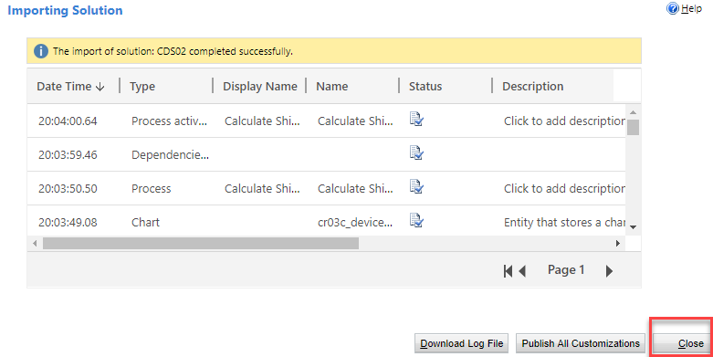

## Task 3: Import the application

In this task, you will import the completed module 3 application.

1. Select **Apps** and click **Import Canvas App**.

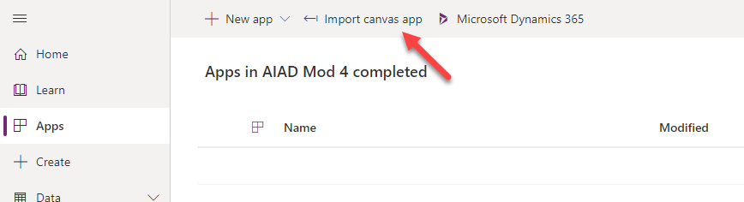

1. Click **Upload**.

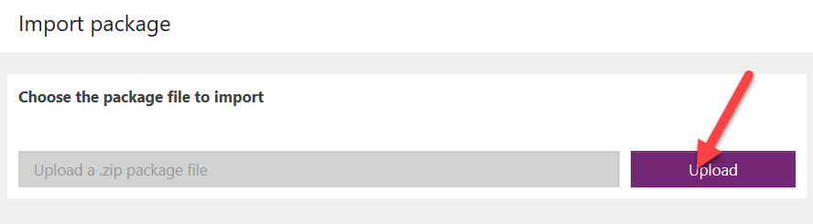

1. Select the Module 4 Completed Application zip file located in Module 4 Complete Solution folder and click **Open**.

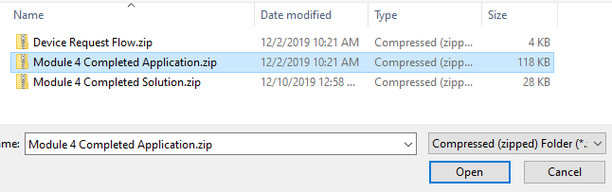

1. Click **Import**.

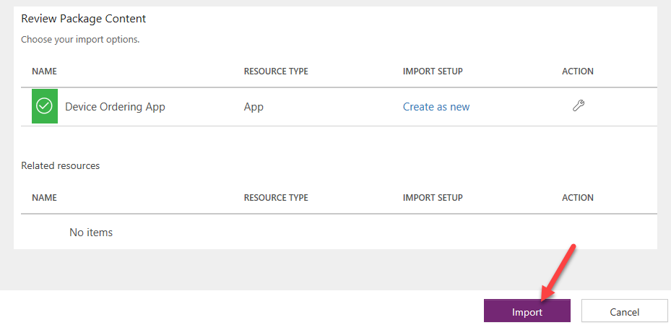

Wait for the application import to complete.

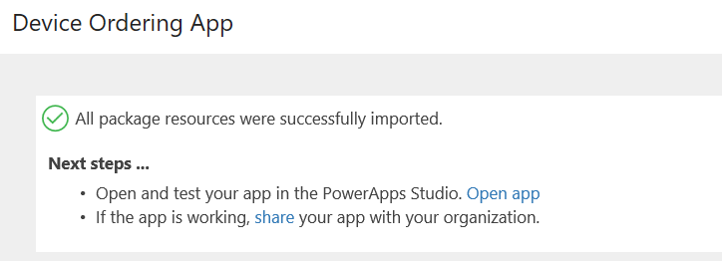

1. Select Home, and then Select Apps, click on the … button of the application you imported and click **Play**.

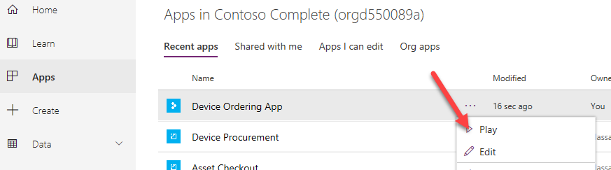

1. Click **Allow**.

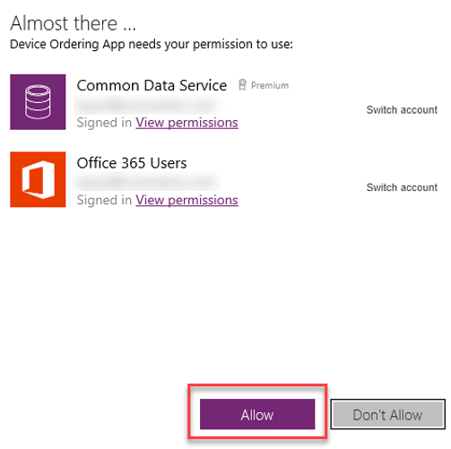

1. Select few devices and click **Compare**.

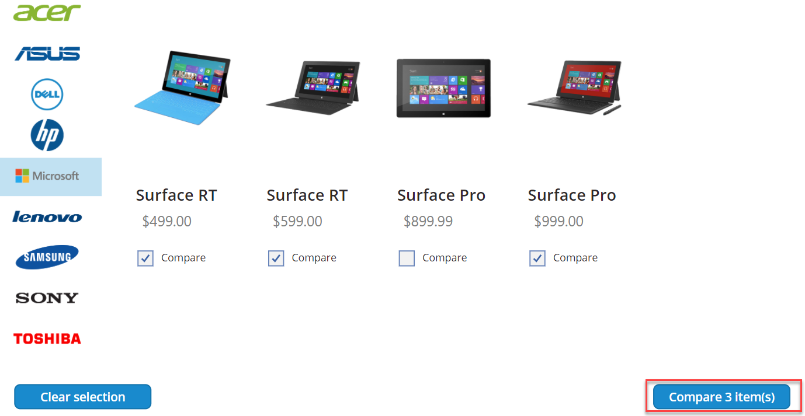

1. Select one of the devices and click **Submit**.

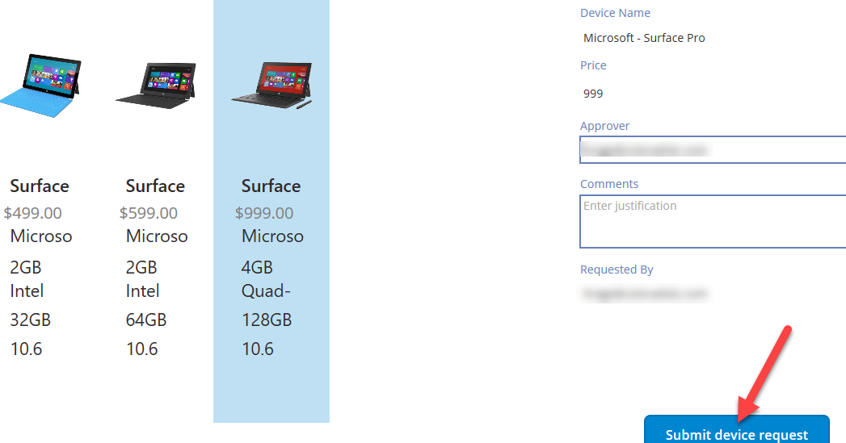

1. Click **OK**.
2. Close the application by simply closing the browser tab.
3. Select **Apps** and start the **Device Procurement** application

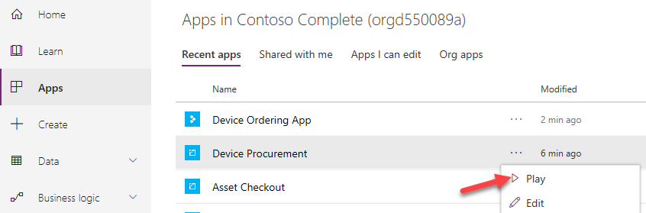

1. Click to open the record you created in the last task.

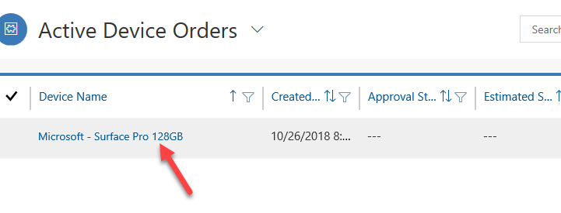

1. The record should load.

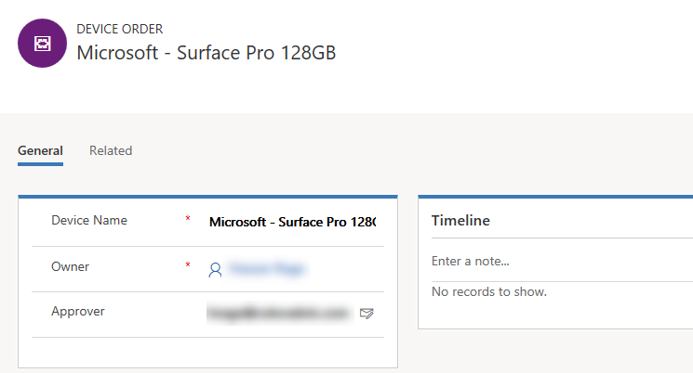

## Task 4: Import Flow

In this task, you will import the Device Approval Flow.

1. Navigate to <https://flow.microsoft.com> login and be sure to select the correct environment (The same one you used when you imported the other components).

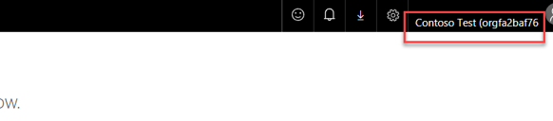

1. Select **My Flows** tab and click **Import**.

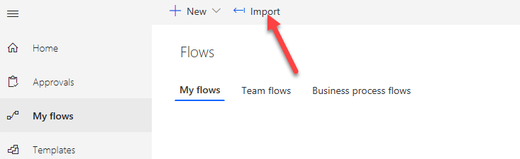

1. Click **Upload**.

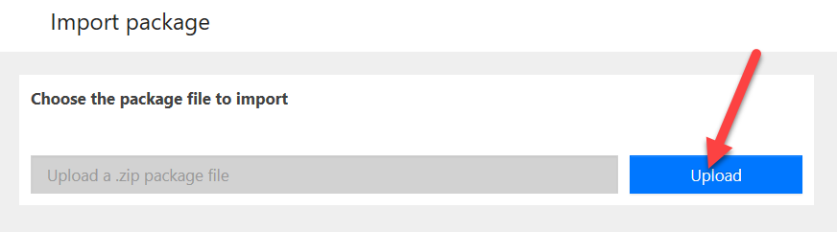

1. Select the **Device Request Flow** zip file located in Module 4 Complete Solution folder and click **Open**.

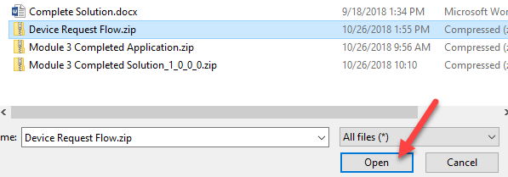

1. Click **Action** for **Common Data Service Connection**.

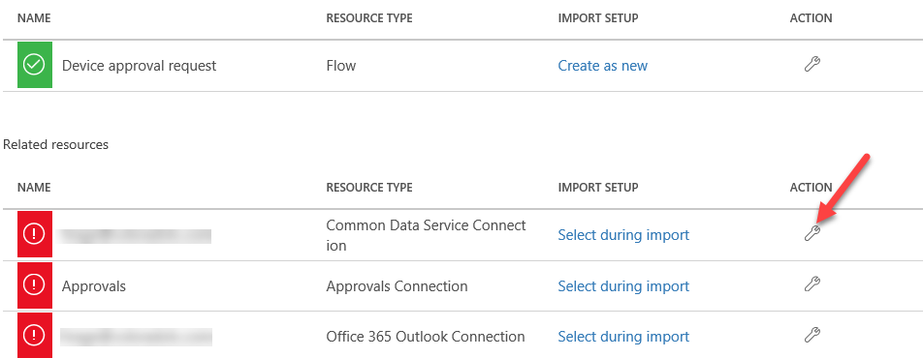

1. Select the available connection and click **Save**.

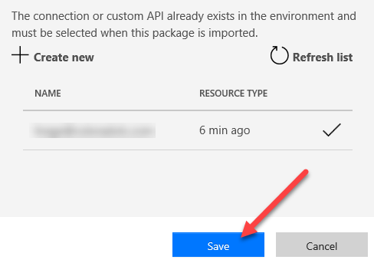

1. Click the **Action** for **Approvals**.

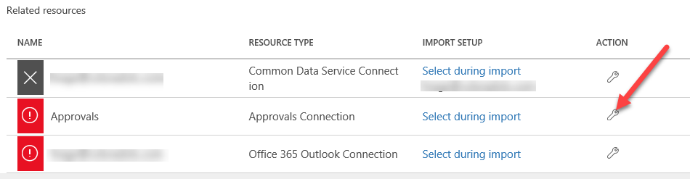

1. Click **Create New**.

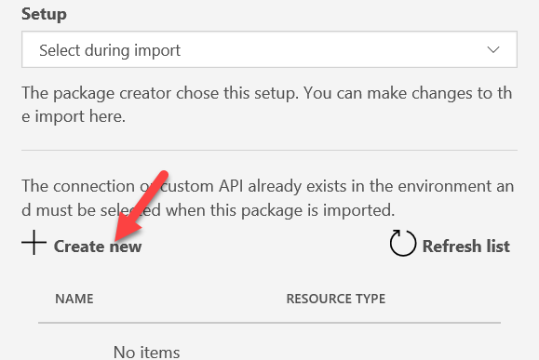

1. Click **New Connection**.

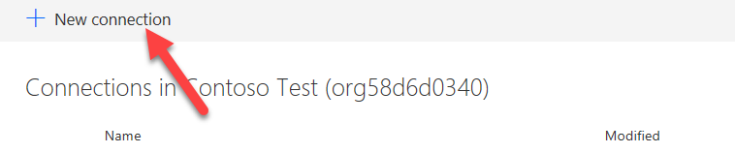

1. Search for **Approvals** and select it.

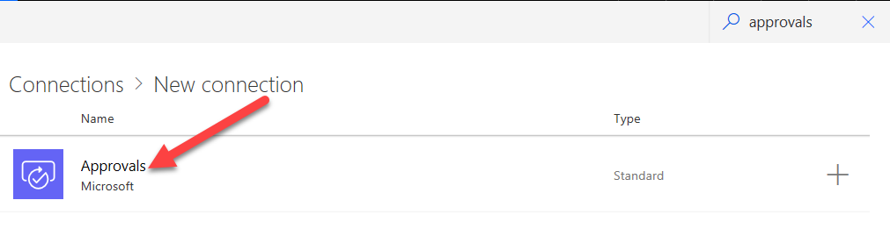

1. Click **Create**.

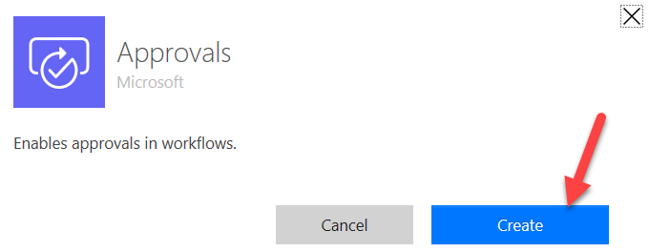

1. Close the connections browser tab.
2. Select the **Approvals** connection you created and click **Save**.

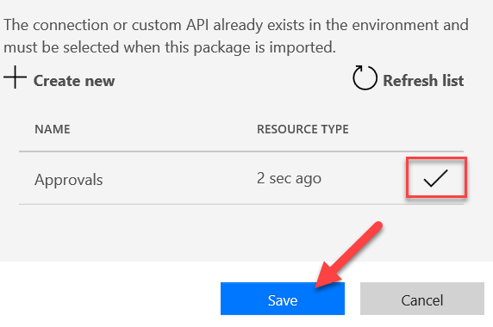

1. Click **Action** for **Office 365 Outlook Connection**.

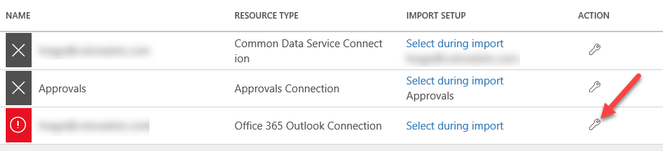

1. Click **Create New.**

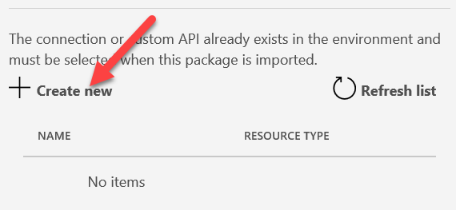

1. Click **New Connection.**

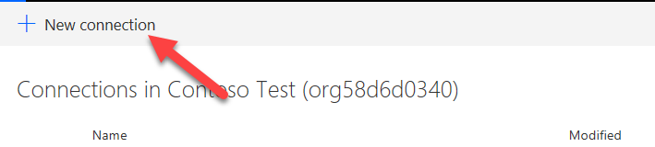

1. Search for **Office 365 Outlook** and select it.

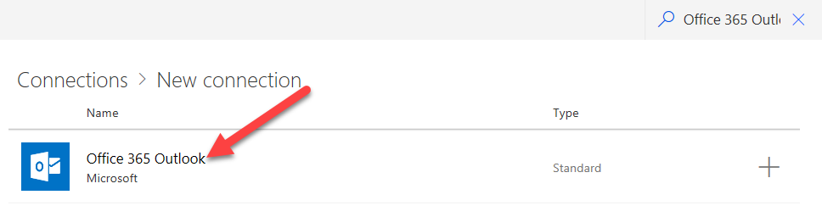

1. Click **Create**.

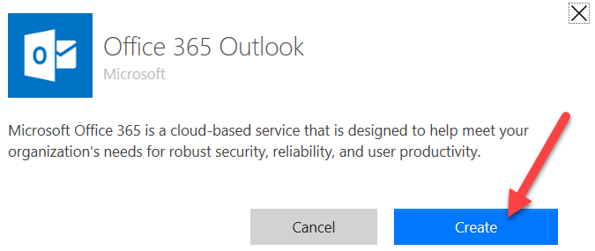

1. Select the User you are logged in as.

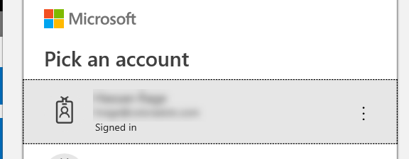

1. Close the connection browser tab.
2. Select the Connection you created and click **Save**.

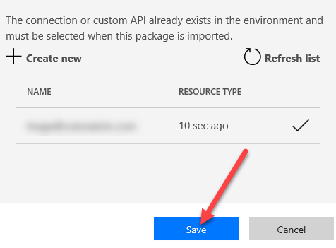

1. Click Import.

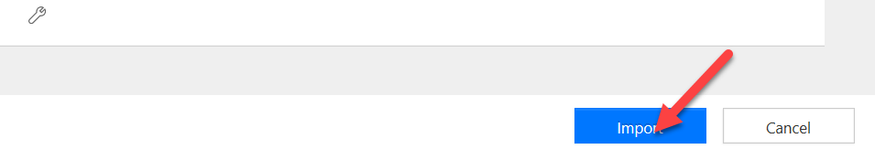

1. Wait for the import to complete.

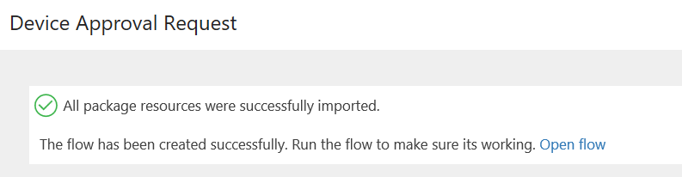

1. You will now have an active **Flow**. Click to open.

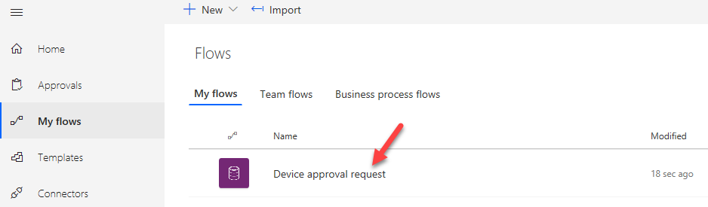

1. Click Edit Flow.

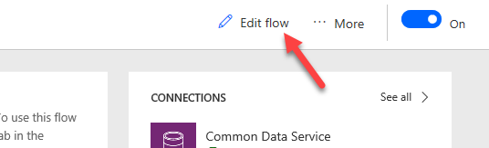

1. The Flow will like the image below.

